Use Case 1: Employee Directory & Department Management
Overview & Business Problem
A classic internal portal service where HR creates employees, assigns them to departments, and fetches directory listings. This teaches clean parent-child relationship mapping, standard pagination, and built-in health monitoring.
Architecture Diagram
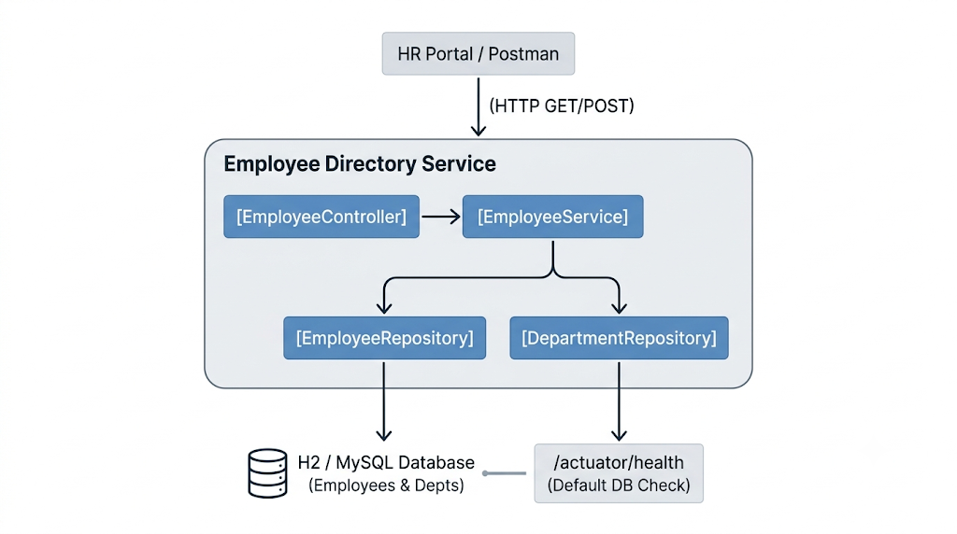
Key Technical Features
- JPA Relationship: Standard @ManyToOne / @OneToMany mapping with FetchType.LAZY between Employee and Department.
- Pagination & Sorting: Using Spring Data's Pageable (GET /api/v1/employees?page=0&size=10&sort=lastName,asc).
- Basic Actuator Health: Out-of-the-box /actuator/health showing database connectivity status ("status": "UP").
Implementation Plan
- Entities: Create Department and Employee entities with standard primary keys and foreign key associations.
- Repositories: Extend JpaRepository<Employee, Long> and JpaRepository<Department, Long>.
- Service Layer: Implement CRUD methods; use @Transactional(readOnly = true) for search operations.
- REST Controller: Expose POST /api/v1/departments, POST /api/v1/employees, and paginated GET /api/v1/employees.
- Actuator: Add spring-boot-starter-actuator and set management.endpoints.web.exposure.include=health,info in application.yml.

